Lab 02- IAM policy
- Go to IAM and click on Policies -> Create Policy
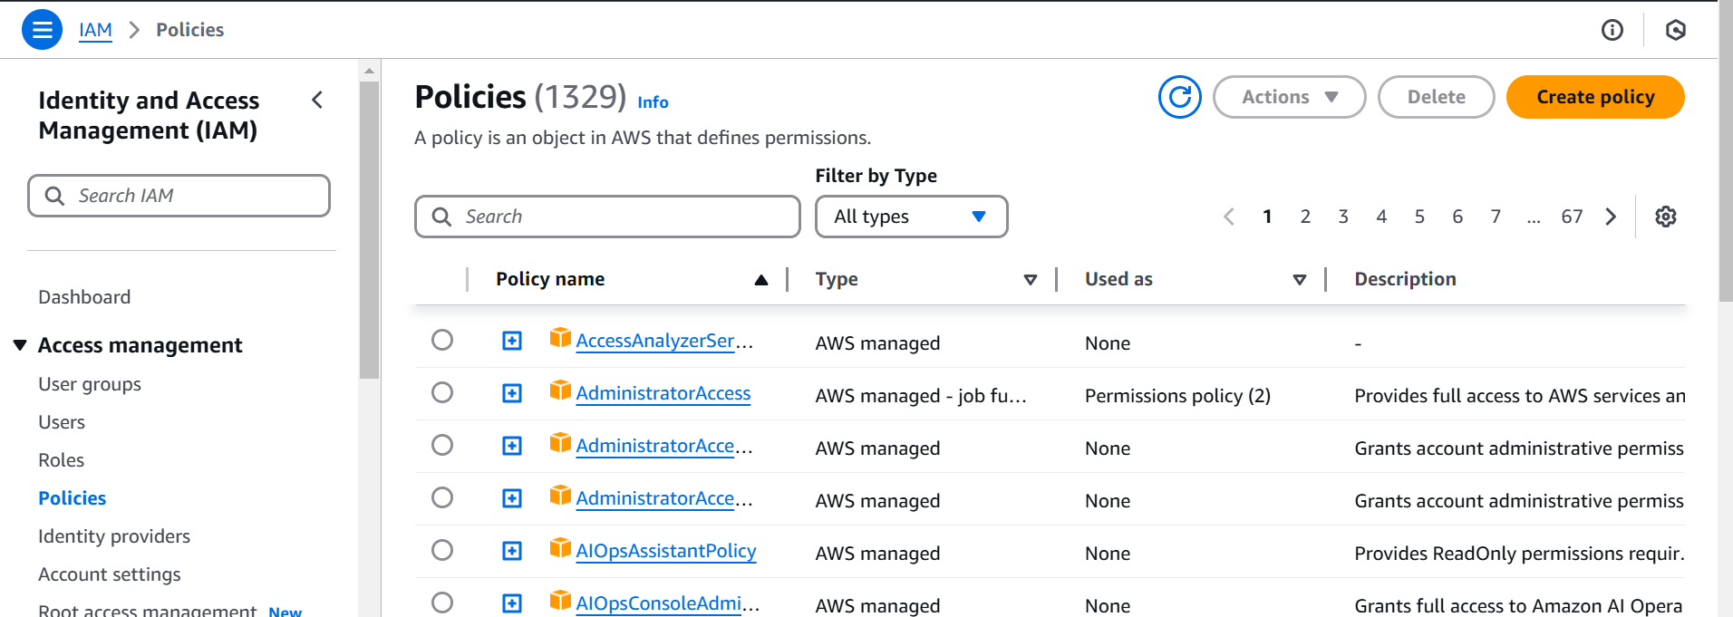

In visual

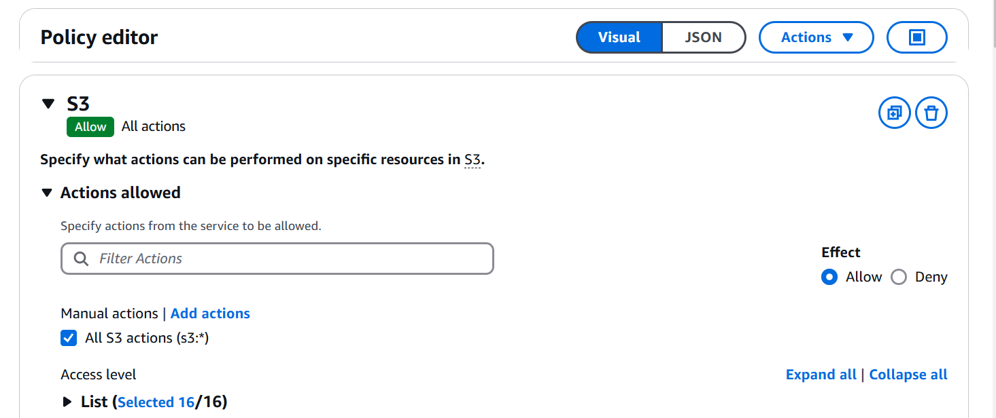

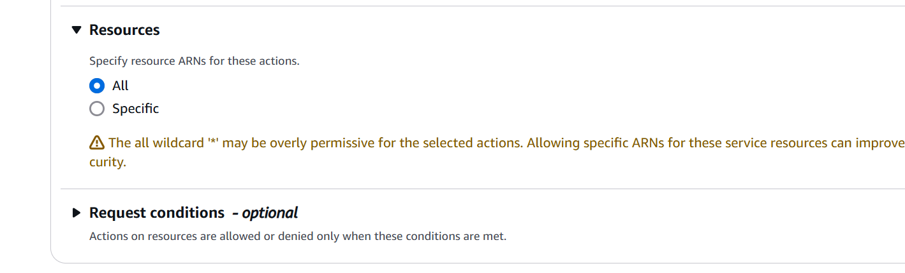

Check json
{
"Version": "2012-10-17",
"Statement": [
{
"Sid": "VisualEditor0",
"Effect": "Allow",
"Action": "s3:*",
"Resource": "*"
}
]
}

Provide policy a name and create policy

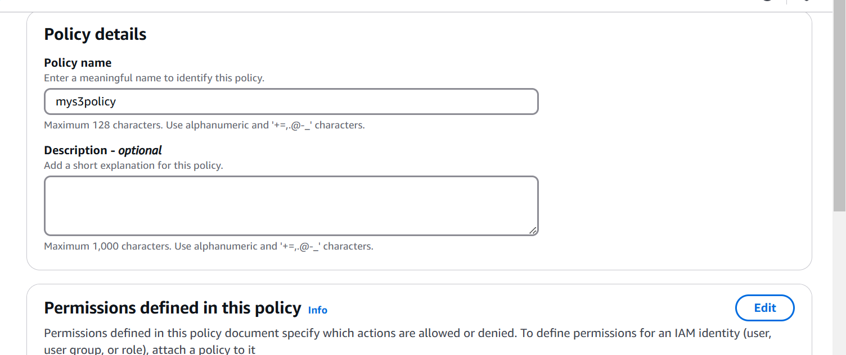

Click on user and click on your user and add permission
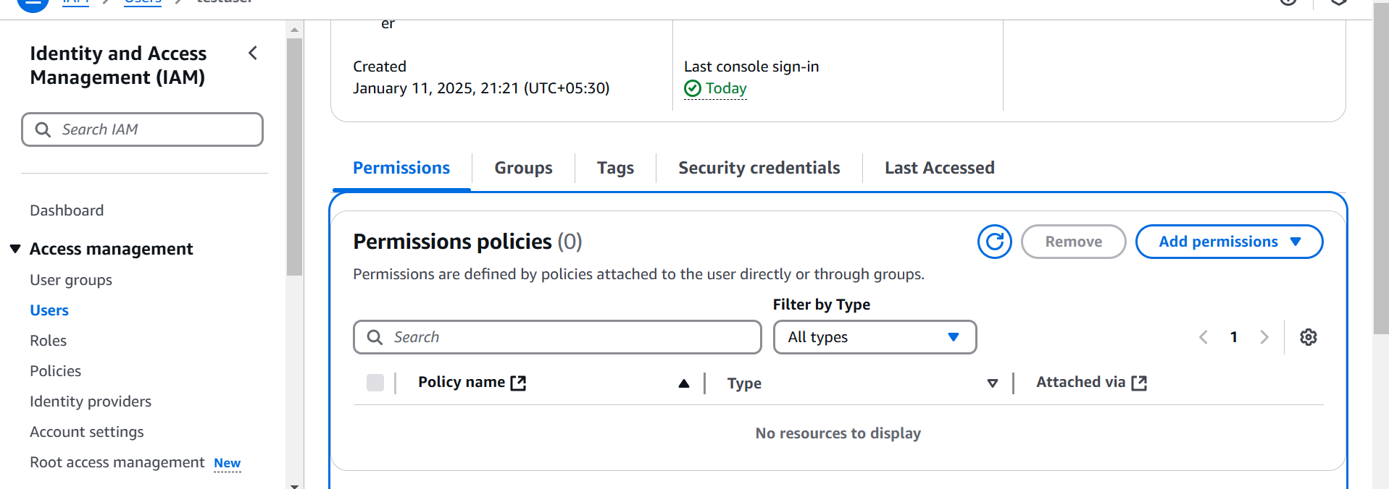

Add Permission
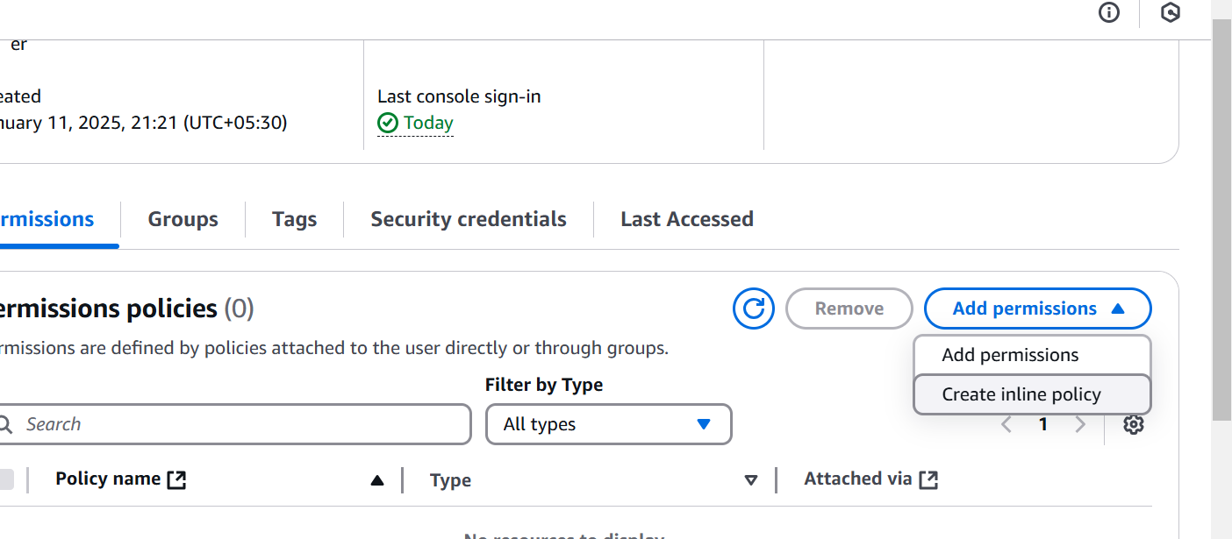
Attach policy directly
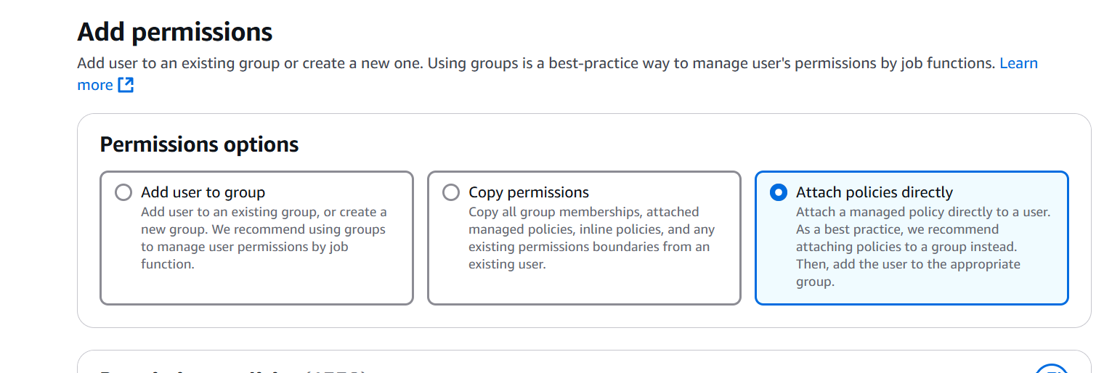

Attach policy
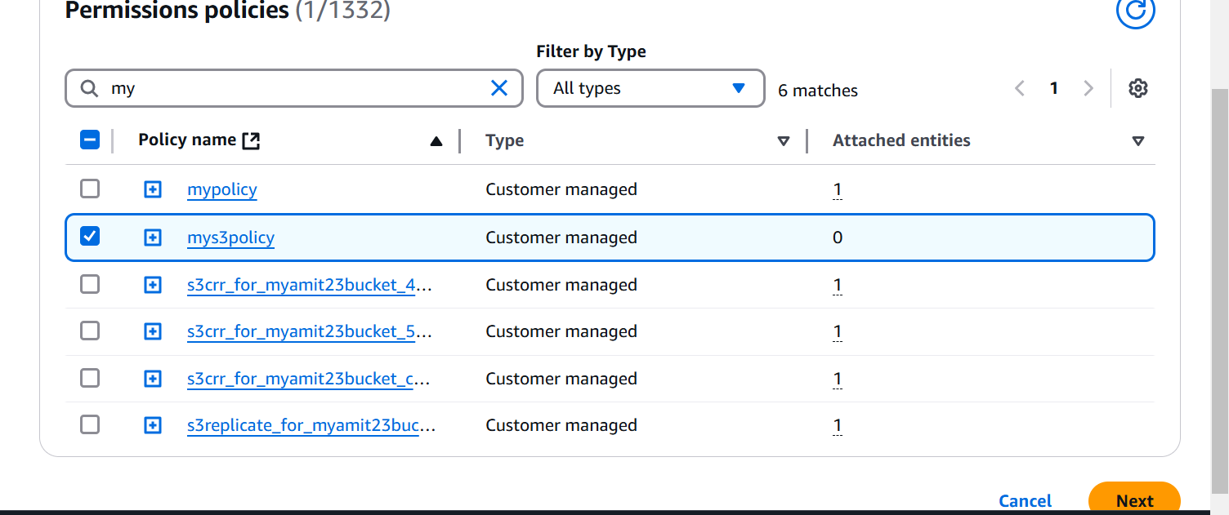

Add permission

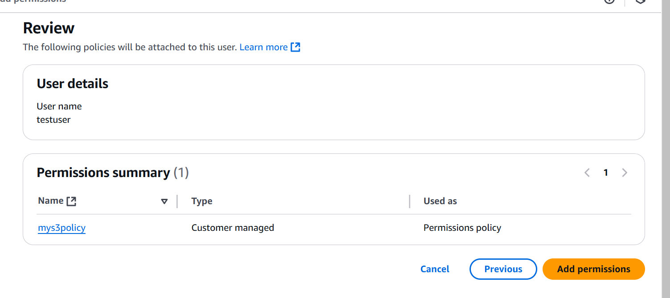

Now go to testuser portal, and check s3 resource

